Food Chains Worksheet
Read the following passage, and then answer the following questions.
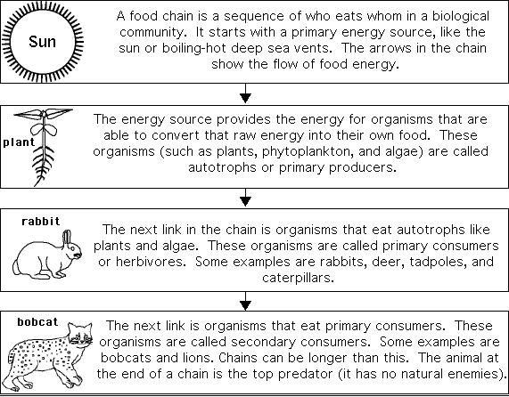

- What do the arrows in a food chain represent?

- What does a food chain starts with?

- What are organisms which make their own food called? (hint: there are two names)

- What is the process plants use to convert energy into food?

- Write a word equation to describe the process in question 4.

- What are organisms that eat plants are called? (hint: there are two names)

- What are secondary consumers?

- What is an animal with no natural enemies called?

- A heterotroph is an organism which gets its energy from eating other organisms. In the food chain above, which organisms are heterotrophic?

